Bahria University,

Karachi Campus



LAB EXPERIMENT NO.

**11**

LIST OF TASKS

|  |  |  |
| --- | --- | --- |
| TASK NO | OBJECTIVE | |
| **1** | Example 1: (A+ B). (A+ C) | |
| **2** | Example 2: A.B + B.C. (B + C) | |
| **3** | Example 3: (𝐴̅)(𝐴 + 𝐵) + (𝐵 + 𝐴)(𝐴 + (𝐵̅) | |
| **4** | Simplify the following equation using Boolean Laws. Construct the Truth Tables to verify that the simplified equation gives the same result as that of the original equation.  𝐹 = (𝐴 + 𝐶)(𝐴𝐷 + 𝐴 𝐷) + 𝐴𝐶 + C | |
|  | |

Submitted On:

Date: 19/12/2022

**Example NO 1 :**

(A+ B). (A+ C) Distributive Law

A.A + A .C+ A .B + B.C Idempotent AND Law

A+ A.C + A.B + B.C Distributive Law

A (1 + C) + A.B + B.C Identity OR Law

A.1 + A.B + B.C Identity AND Law

A +A.B+ B.C Distributive Law

A (1 + B) + B.C Identity OR Law

A.1 + B.C Identity AND Law

A + B.C

**Output:**

* 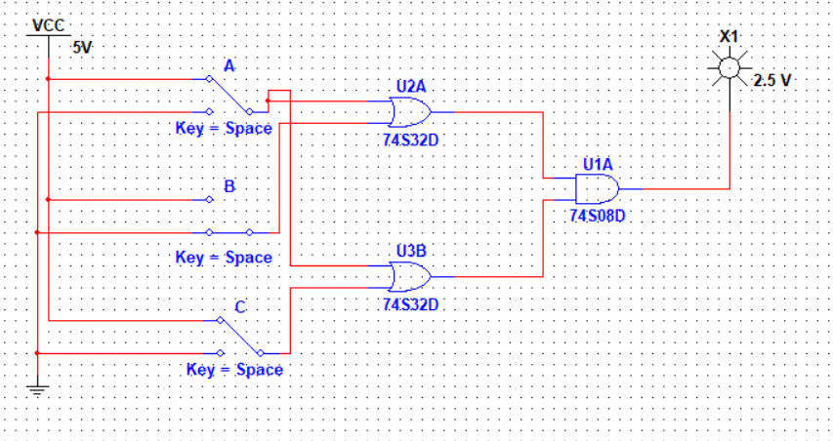**(A+ B). (A+ C) :**
* **A + B.C:**

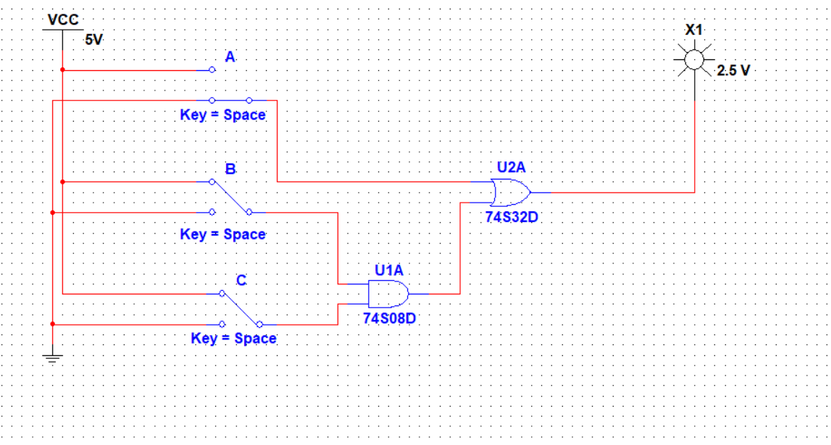

**Example No 2:**

A.B + B.C. (B + C)

A.B + B .C .B + B.C.C Distributive Law

A.B + B .B .C + B .C .C Commutative Law

A.B +B.C + B.C Idempotent Law

A.B +B.C Idempotent Law

B. (A+C) Distributive Law

**Output:**

* **A.B + B.C. (B + C)**

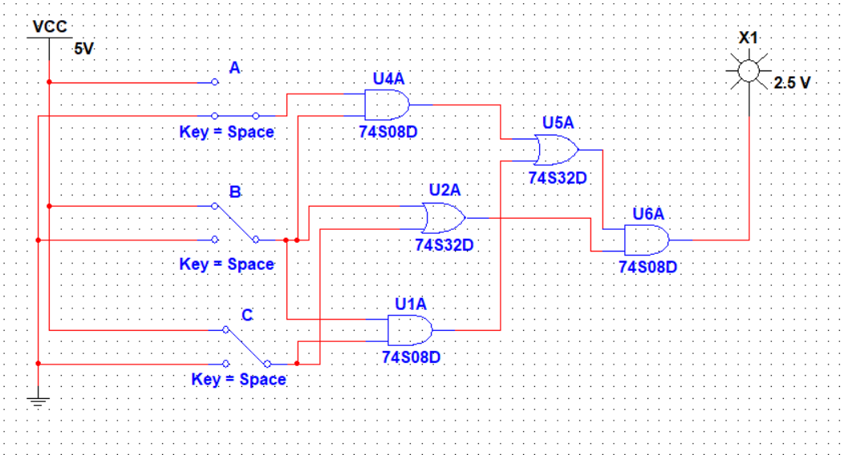

* 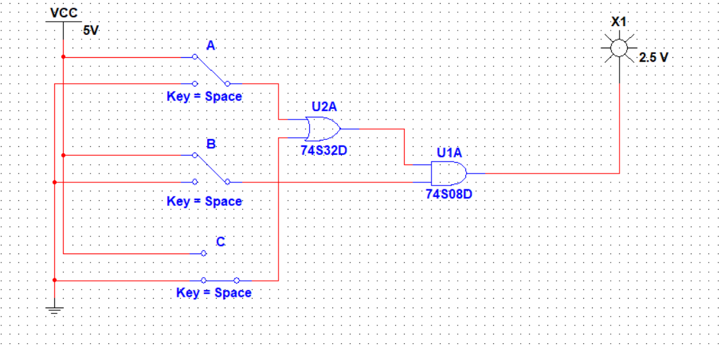**B. (A+C):**

**Example No 3:**

𝐴̅)(𝐴 + 𝐵) + (𝐵 + 𝐴)(𝐴 + (𝐵̅)

( 𝐴̅ ) 𝐴 + (𝐴̅ ) 𝐵 + (𝐵 + 𝐴) 𝐴 + (𝐵 + 𝐴)𝐵̅ Distributive Law

( 𝐴̅ ) 𝐵 + (𝐵 + 𝐴) 𝐴 + (𝐵 + 𝐴) 𝐵̅ Complement Law

( 𝐴̅ ) 𝐵 + 𝐵𝐴 + 𝐴𝐴 + 𝐵𝐵̅+ 𝐴 𝐵̅ Distributive Law

( 𝐴̅ ) 𝐵 + 𝐵𝐴 + 𝐴 + A 𝐵̅ Idempotent Law

𝐵 (𝐴̅ + 𝐴) + 𝐴 (1 + 𝐵̅ ) Distributive Law

𝐵.1 + 𝐴.1 Idempotent & Annulment Law

𝐵 + 𝐴 Identity

𝐴 + 𝐵

**Output:**

* 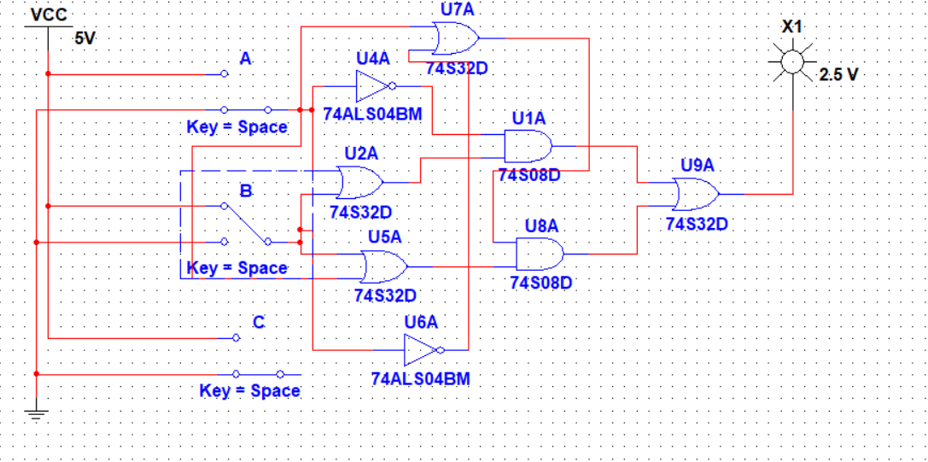**𝐴̅)(𝐴 + 𝐵) + (𝐵 + 𝐴)(𝐴 + (𝐵̅):**
* **𝐴 + 𝐵:**

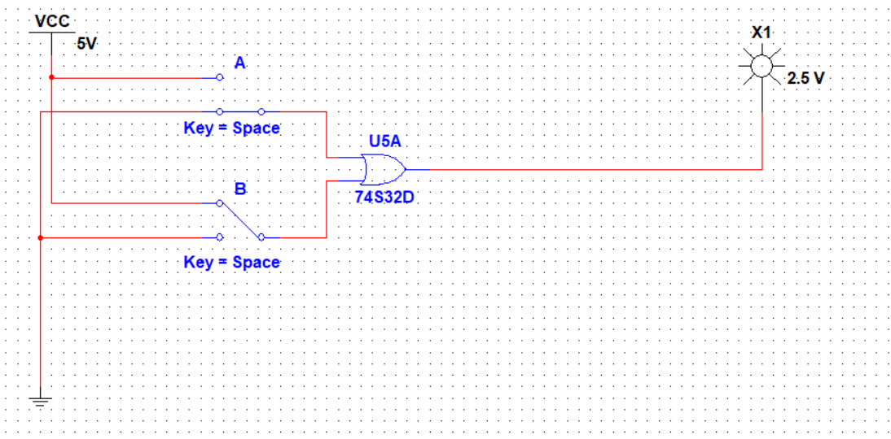

**Task No 1 : Simplify the following equation using Boolean Laws. Construct the Truth Tables to verify that the simplified equation gives the same result as that of the original equation.**

**𝐹 = (𝐴 + 𝐶)(𝐴𝐷 + 𝐴 𝐷) + 𝐴𝐶 + C**

**Solution:**

|  |  |  |  |  |  |  |  |  |  |
| --- | --- | --- | --- | --- | --- | --- | --- | --- | --- |
| **Input: A** | **Input: B** | **Input: C** | **Input: D** | **AD** | **AC** | **A+C** | **AD+AD** | **𝐴𝐶 + C** | **(𝐴 + 𝐶)(𝐴𝐷 + 𝐴 𝐷) + 𝐴𝐶 + C** |
| 0 | 0 | 0 | 0 | 0 | 0 | 0 | 0 | 0 | 0 |
| 0 | 0 | 0 | 1 | 0 | 0 | 0 | 0 | 0 | 0 |
| 0 | 0 | 1 | 0 | 0 | 0 | 1 | 0 | 1 | 1 |
| 0 | 0 | 1 | 1 | 0 | 0 | 1 | 0 | 1 | 1 |
| 0 | 1 | 0 | 0 | 0 | 0 | 0 | 0 | 0 | 0 |
| 0 | 1 | 0 | 1 | 0 | 0 | 0 | 0 | 0 | 0 |
| 0 | 1 | 1 | 0 | 0 | 0 | 1 | 0 | 1 | 1 |
| 0 | 1 | 1 | 1 | 0 | 0 | 1 | 0 | 1 | 1 |
| 1 | 0 | 0 | 0 | 0 | 0 | 0 | 0 | 0 | 0 |
| 1 | 0 | 0 | 1 | 1 | 0 | 0 | 1 | 1 | 1 |
| 1 | 0 | 1 | 0 | 0 | 1 | 1 | 0 | 1 | 1 |
| 1 | 0 | 1 | 1 | 1 | 1 | 1 | 1 | 1 | 1 |
| 1 | 1 | 0 | 0 | 0 | 0 | 0 | 0 | 0 | 0 |
| 1 | 1 | 0 | 1 | 1 | 0 | 0 | 1 | 1 | 1 |
| 1 | 1 | 1 | 0 | 0 | 1 | 1 | 0 | 1 | 1 |
| 1 | 1 | 1 | 1 | 1 | 1 | 1 | 1 | 1 | 1 |

**Using Boolean Laws:**

**(𝐴 + 𝐶)(𝐴𝐷 + 𝐴 𝐷) + 𝐴𝐶 + C**

**(A+C) (AD) + AC + C Idempotent**

**(A+C) (AD) + C (A+1)**

**(A+C) (AD) + C (1) Annulment**

**(A+C) (AD) + C**

**AAD + ADC + C Distributive Law**

**AD + ADC + C Idempotent**

**AD + C (AD + 1)**

**AD + C (1) Annulment**

**AD + C**

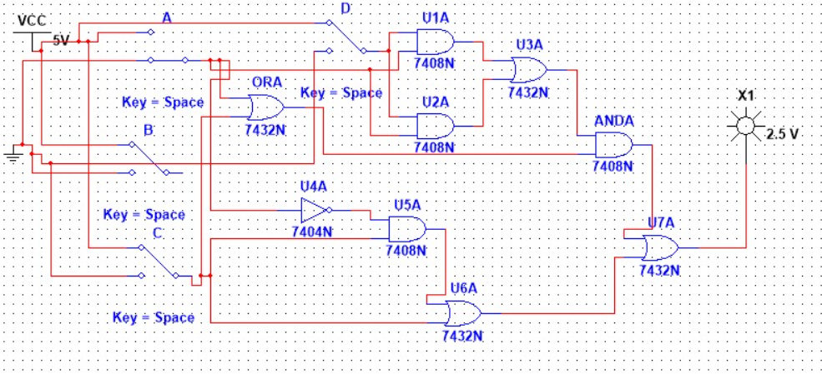**Output:**

